Government College of Engineering, Jalgaon.
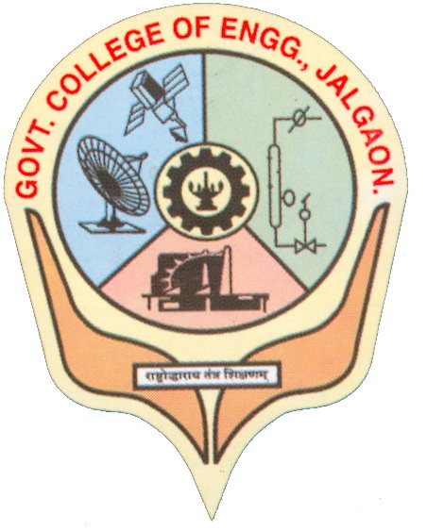
National Highway No. – 06, Jalgaon, Pin-425002.
Phone:02572281522; Fax 02572281319;
Web:www.gcoej.ac.in; email:princoej@rediffmail.com

Application for Migration Certificate

Photo
To,
The Dean Academics,
Government College of Engineering, Jalgaon - 425002
Respected Sir,
I request to issue me the migration certificate as I have passed final year B.Tech./M. Tech. in ______________________________Engineering and paid the prescribed fees Rs ______
(in words Rs___________________________) vide receipt number__________ dated__/__/20__.
I am furnishing my details as given below.
Thanking You. Yours Faithfully,
Date : / / 20
Signature of the Candidate
Candidate’s Information.
1. | Name in Full as appeared on :  B. Tech / M. Tech grade report  (In Capital Letters)
2. | Branch :
3. | Permanent Registration Number:
4. | Category: Caste and Sub-cast:
5. | Gender:
6. | Address for Communication, :  Mobile Number and e-mail
7. | Year and Number of Provisional : Degree Certificate

Enclosure : Photo copy of provisional degree certificate.

Date : / / 20 Signature of the Candidate

INSTRUCTIONS TO CANDIDATES

- The fee for Migration Certificate is (a) Rs. 200/- up to 5 years from passing examination (b) Rs. 500/- more than 5 years from passing examination which may be remitted by Demand Draft of the Nationalised/Scheduled/Private sector commercial Bank drawn in favour of Principal, Government College of Engineering, Jalgaon or cash in the institute’s office along with the application form.

- The Fee once paid for Migration Certificate shall not be returned under any circumstances.

- Students are advised to ensure that the attested photo-copy of Transference Certificate and Grade Report of final year examination is enclosed with the application form.

- Migration Certificate will be given to the candidate in person only.

